

A word finding game against time!

**.NET Boggle Game Programming Assessment Task**

**Aim / Problem**  
To design a computer version of the Boggle game

**The Game**In the game Boggle, sixteen dice (with letters on each face) are shaken to create a grid of sixteen random letters. A sand timer counting 3 minutes is then started and the player is to find as many words as he/she can find by adjoining the letters in the grid. When the sand timer reaches 0, the player would add up the value of each word (based on the word’s length)

**Solution**To create a functional Boggle game in Visual Basic .NET with Microsoft Visual Studio.  
This involves reproducing a grid of random letters and a 3 minute timer. The player will be able to enter the words he/she finds into the game, and the scoring at the end of the game will be automated.

**.NET Boggle Game Features**> Multiple game durations, including an unlimited mode  
> User word input  
> Display of entered words  
> Audible feedback (ding noise) for found words  
> Custom word lists  
> Functional word validation  
> Player score calculation  
> Maximum score calculation  
> Coloured taskbar indicator

**.NET Boggle Features (explained)**

Multiple game durations, including an unlimited mode  
Players can change the length of each game, choosing either 30 seconds, 1 minute, 1.5 minutes, 2 minutes, 3 minutes and 5 minutes. An unlimited mode is also available which does not have a time limit.

User word input  
Instead of writing the words the player sees down on paper, the player can type the words into the game, pressing [Enter] to submit the word.

Display of entered words  
The software displays a list of words that the user has entered.

Audible feedback (ding noise) for found words  
If a new word is found, a ding noise will be played/

Custom word lists  
.NET Boggle allows custom word lists (to check entered words against) to be used.  
Place a file named *lexicon.txt* containing lowercase words separated by a new line in the same directory as the game’s executable to use.

Functional word validation  
The game checks that the entered word is possible in the game board

Player score calculation  
At the end of the game, the program will display the player their final score.

|  |  |
| --- | --- |
| Word Length | Score Value |
| 3 – 4 | 1 |
| 5 | 2 |
| 6 | 3 |
| 7 | 5 |
| 8+ | 11 |

Maximum score calculation  
During a game, the highest possible score is shown in the top right corner of the game.

Coloured taskbar indicator  
The taskbar icon for the game will change colour accordingly to the remaining time.

**Screen Design Mockups**

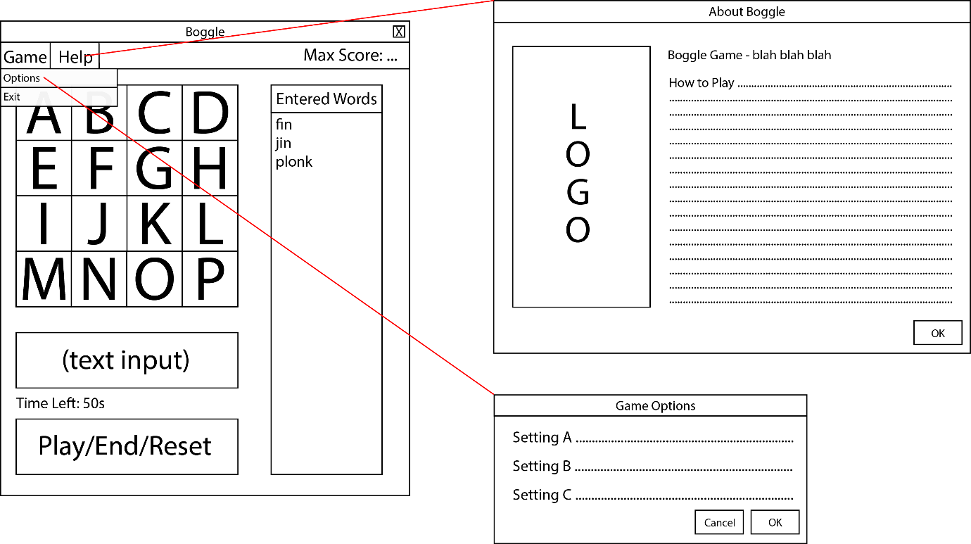

**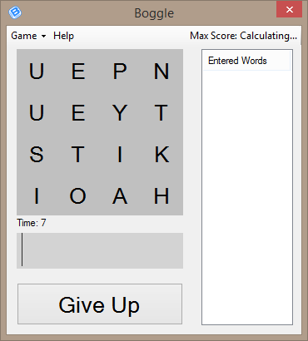  
Finished Game Screen**

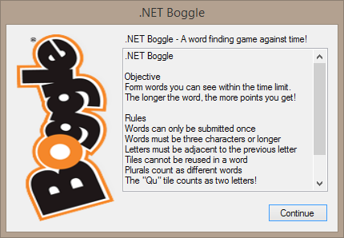

**About/Help Screen**

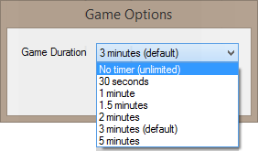  
**Options Screen**

**Explanatory Notes** (refer to code comments for more information)

Overall Game Function - minimal

Dice shuffling (*Boggle.vb > Dice > Game Functions > Shuffle*)

Word Validation (*Boggle.vb > Dice > Game Utilities > WordLoop / ValidateWord)*

This function searches for a letter A, then searches for the next letter B that is around the previous letter A. For each letter B the function will self-execute itself and repeat.  
  
Public Function WordLoop(i As Integer, word As List(Of Char), previous As Label, exclude As List(Of Label))

i is the current letter’s position in the word. When this value reaches the length of the whole word, then the word is deemed to be found, and the word is validated.

**Gantt Chart**

